Test Report

for

Teamwork System

Prepared by Tian Zhanming, Zhang Qiaomu, Zhang Haibin, Li Jiajia

Software Development Workshop III

2020/5/13

Contents

1. Brief description 1

2. Test date and performer 1

3. References 1

4. Error report 1

5. Appendix 2

# Brief description

This test costs totally 30 minutes, 20 minutes for recording and generate the script and 10 minutes for replaying the scripts, all the testing case are passed without error.

# Test date and performer

The test date is May 13th, 2020 and the tester is Tian Zhanming, Zhang Qiaomu, Zhang Haibin, Li Jiajia

# References

Z. M. Tian, et al., “Software Requirements Specification for Teamwork System v1.4” May. 13, 2020.

Z. M. Tian, et al., “Test Plan Eagle V1.0” May. 13th, 2020

# Error report

The test is run without error thus there is no error report

# Appendix

Figure 1 Modifying submission page entering

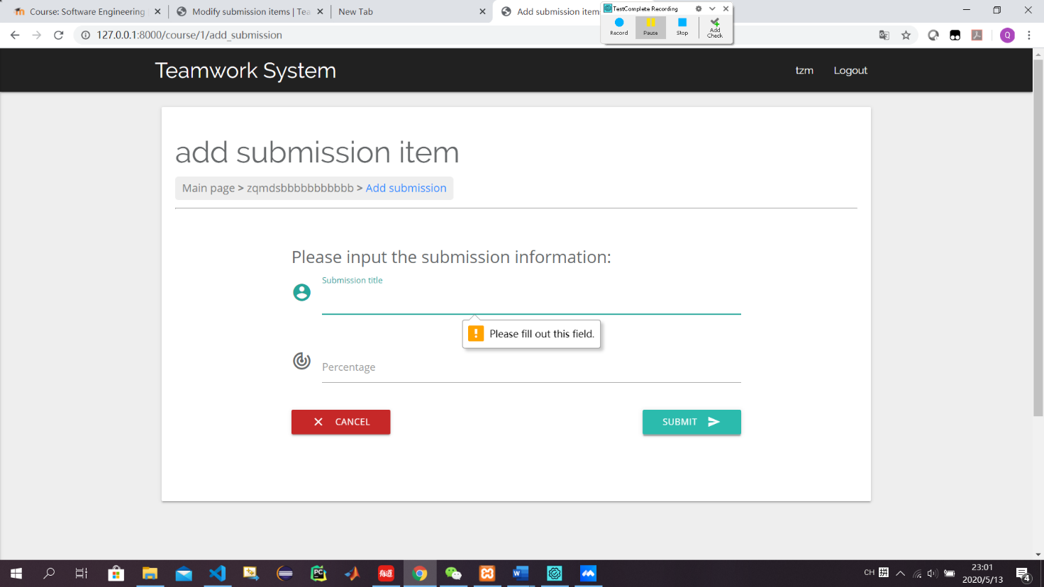

Figure 2 input empty information to submission title

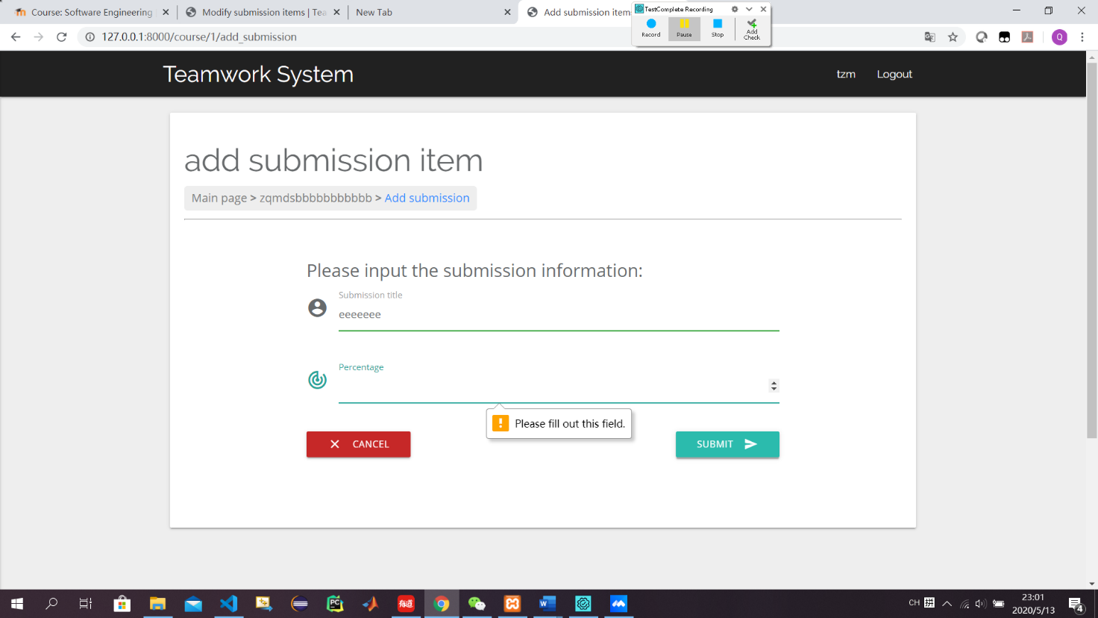Figure 3 input empty information to percentage

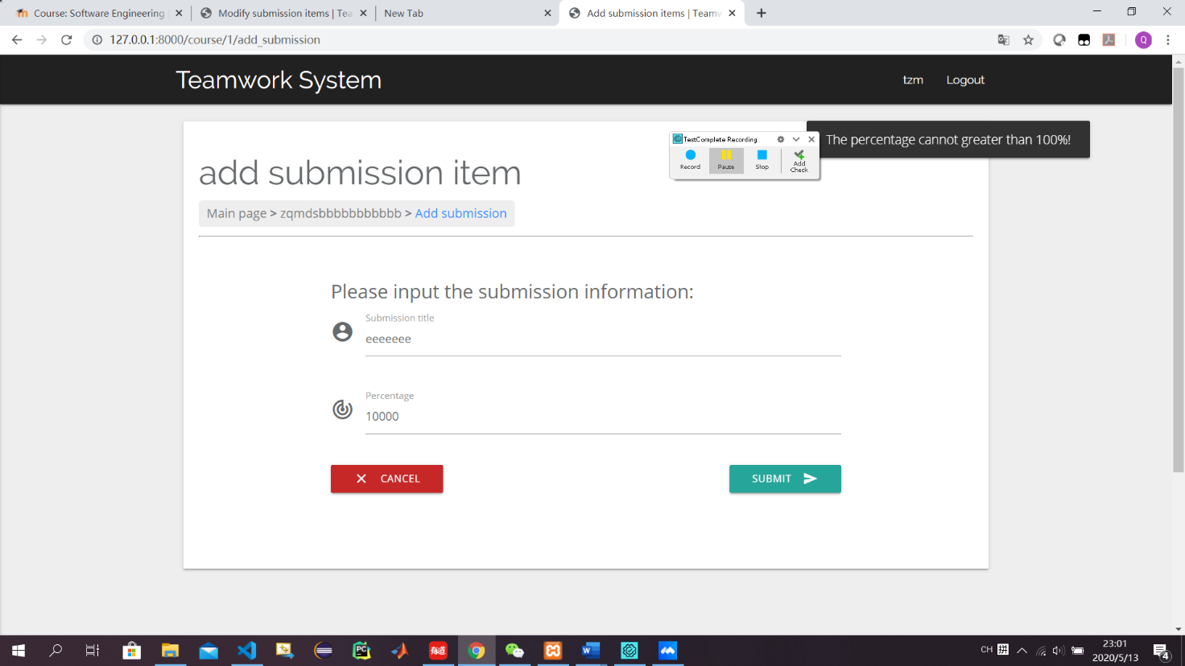

Figure 4 input percentage over than 100%

Figure 5 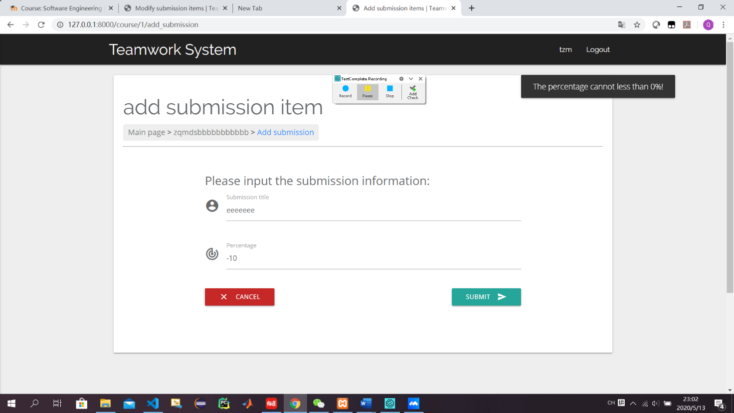input percentage less than 0%

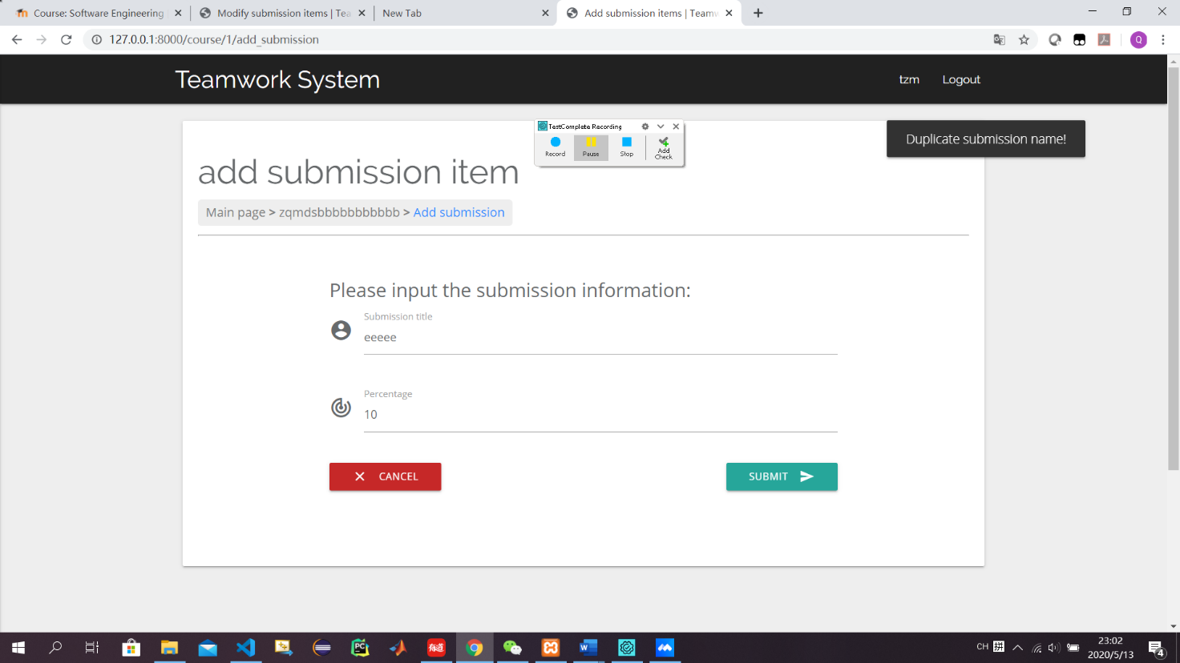

Figure 6 input percentage with duplicate submission name

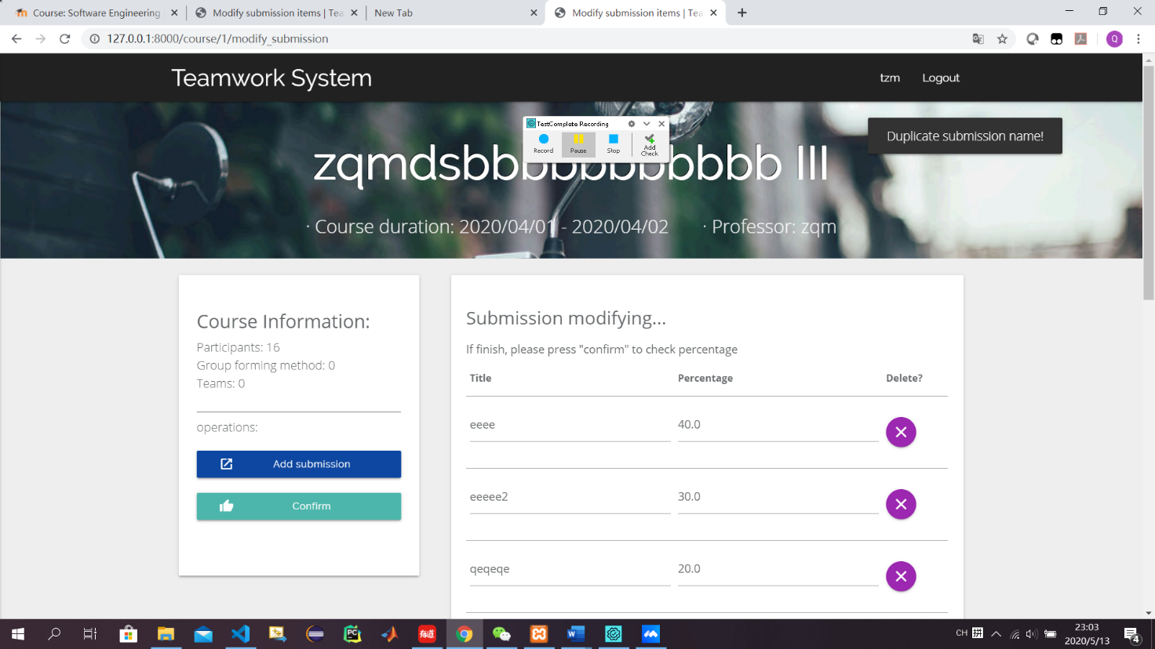Figure 7 input duplicate submission name when modifying

Figure 8 input empty title when modifyin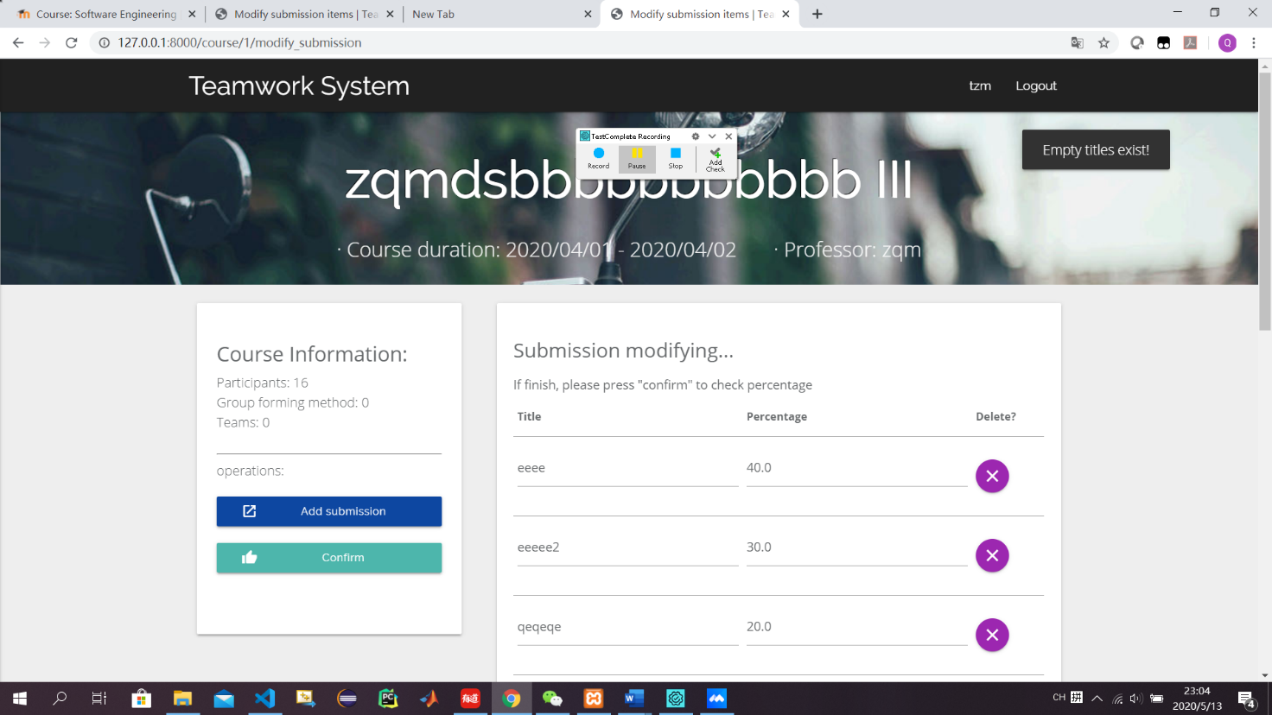g

Figure 9 input empty percentage when modifying 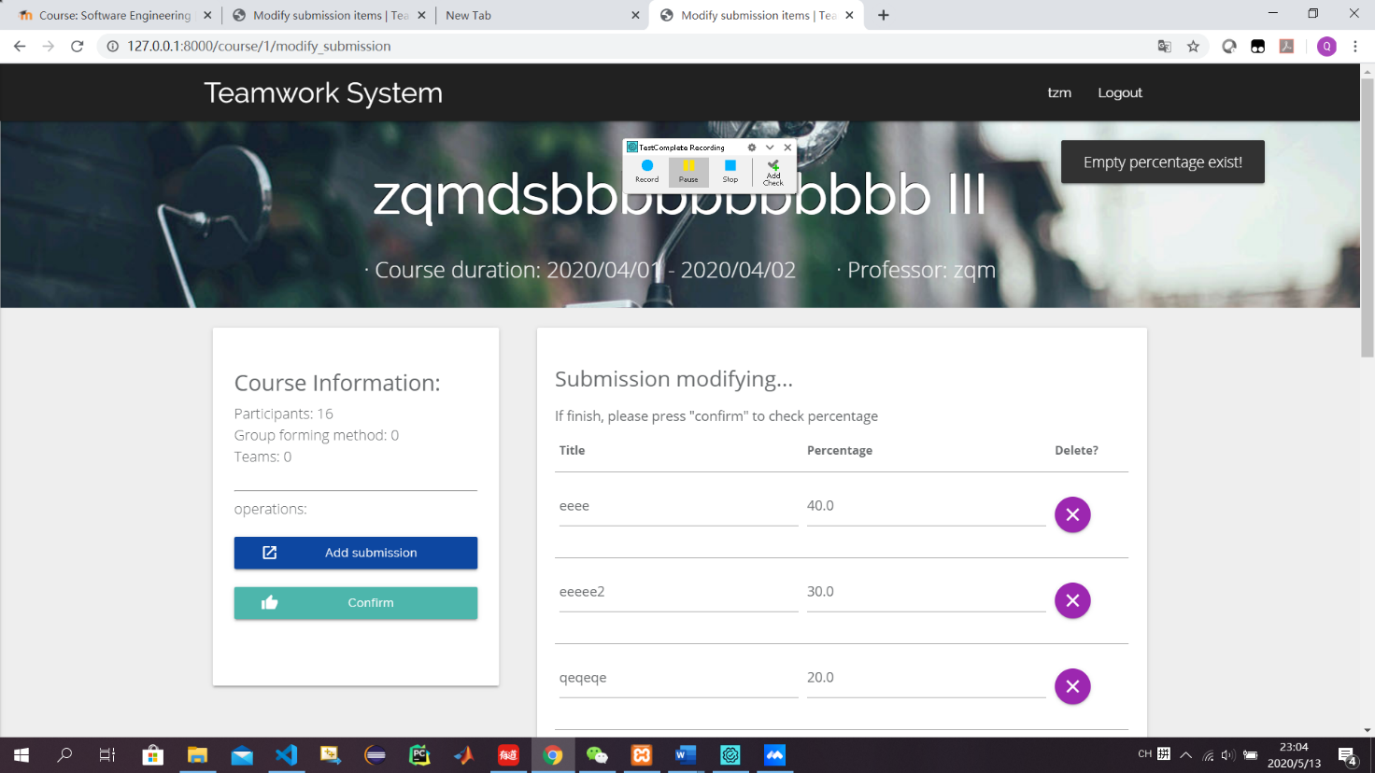

Figure 10 input percentage not 100 percentage when modifying 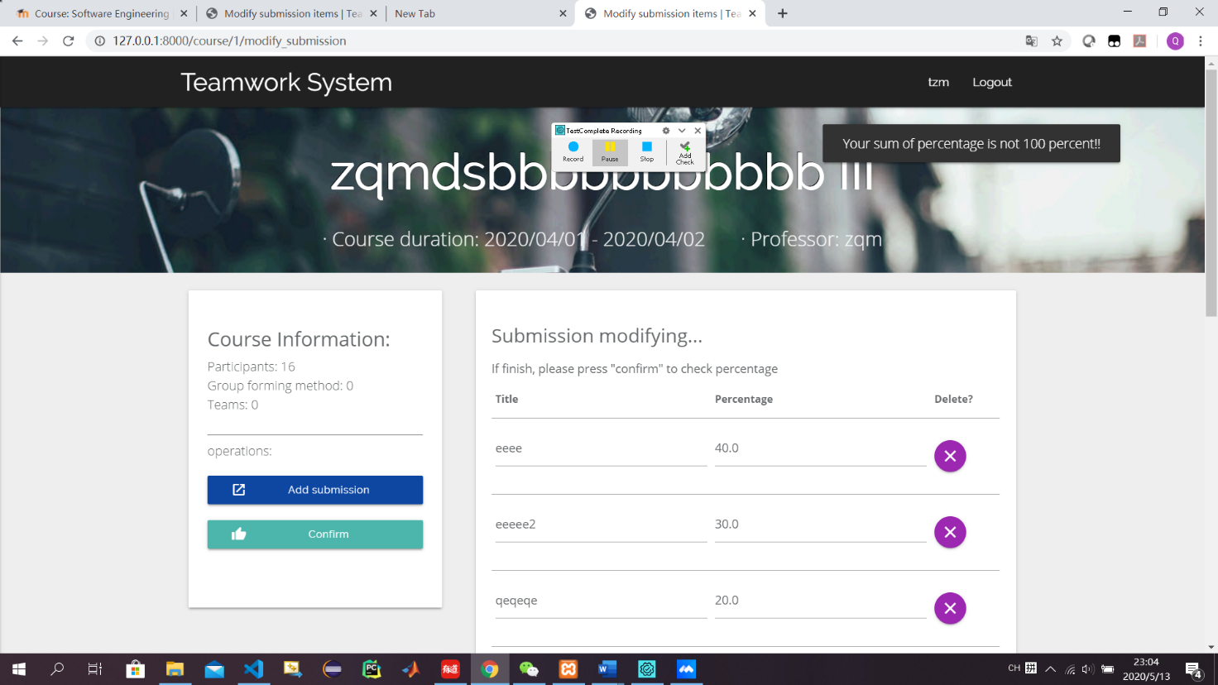

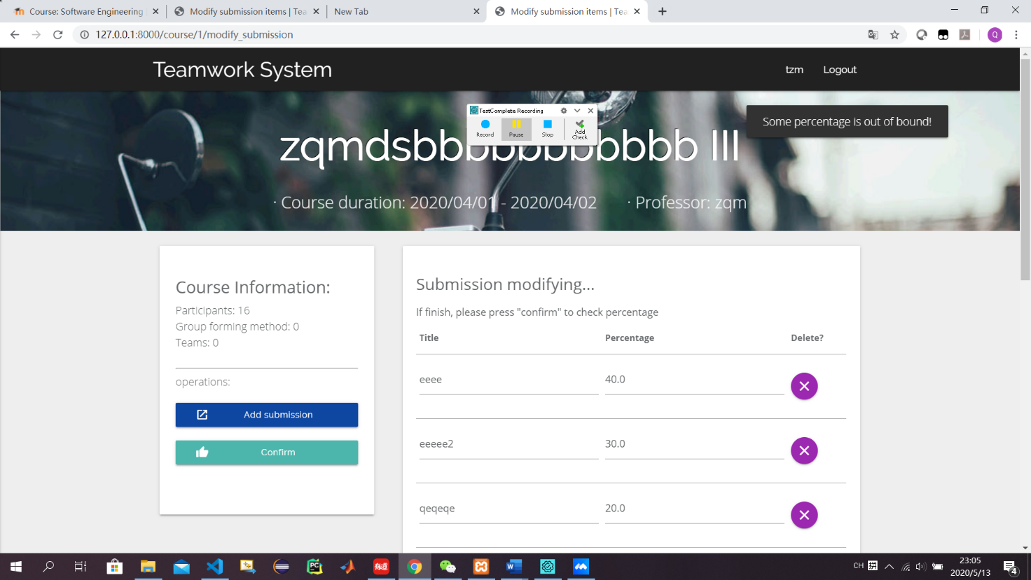Figure 11 input percentage is out of bound

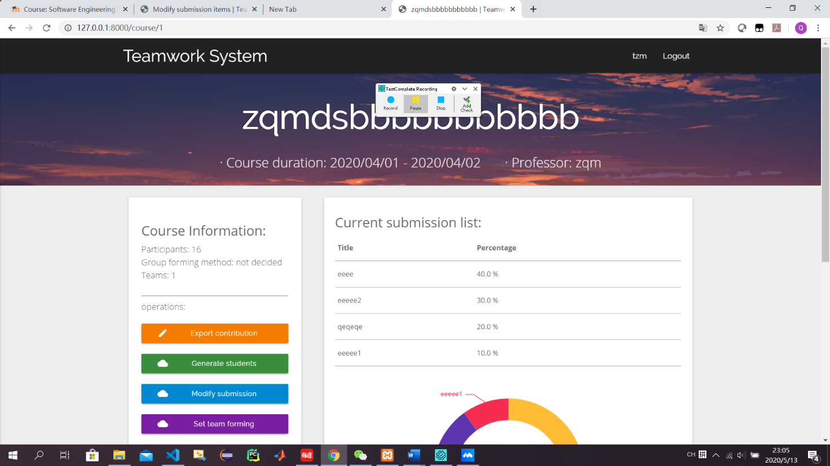

Figure 12 jump to course page when input correct information